**OUTPUT:**

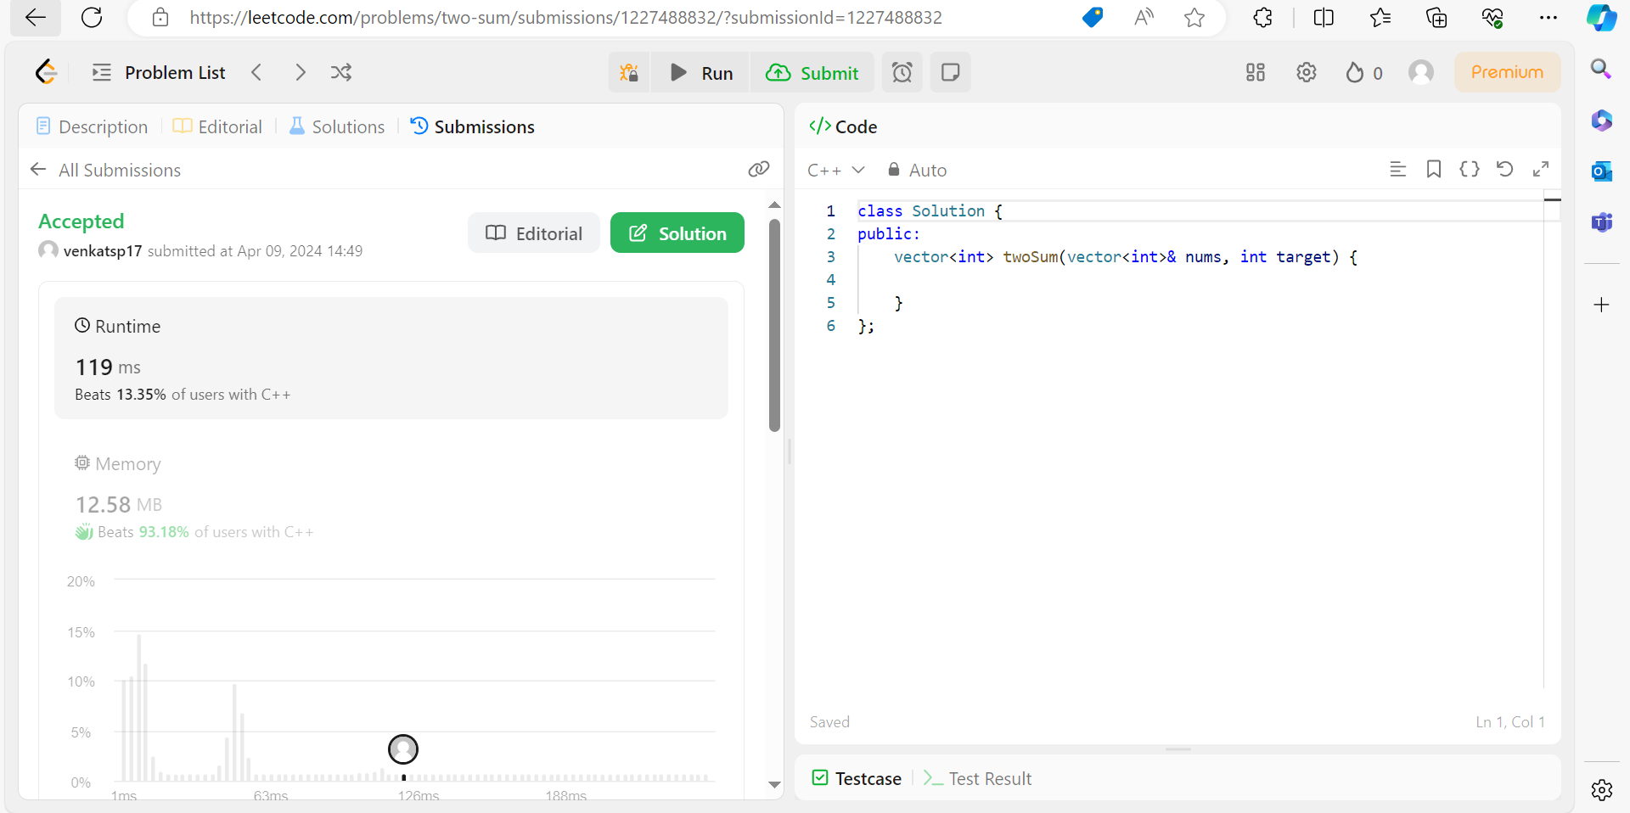

**CODE:**

class Solution {

public:

vector<int> twoSum(vector<int>& nums, int target) {

int sum =0;

vector<int> arr;

for(int i=0;i<nums.size()-1;i++){

for(int j=i+1;j<nums.size();j++){

sum = nums[i] + nums[j];

if(sum==target){

arr.push_back(i);

arr.push_back(j);

break;

}

}

}

return arr;

}

};